CaseManagement_CreationOfCase_Instance23_06-Aug-2018_02-44-11_AM_MouseClickActiononStaleElement.png

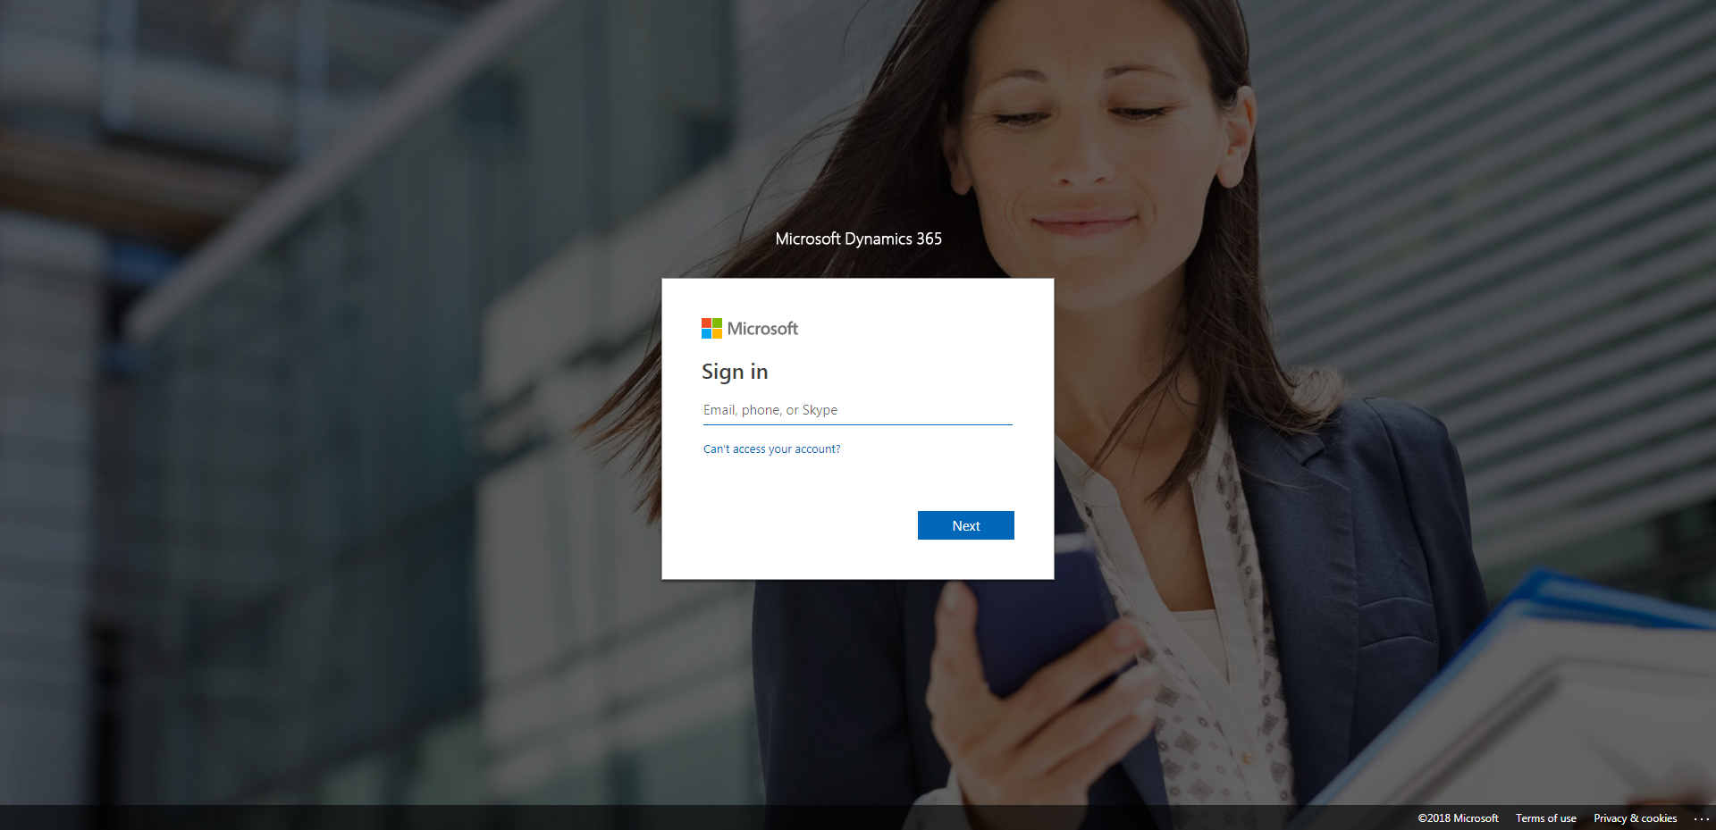

CaseManagement_CreationOfCase_Instance23_06-Aug-2018_02-44-36_AM_SingleSignOn.png

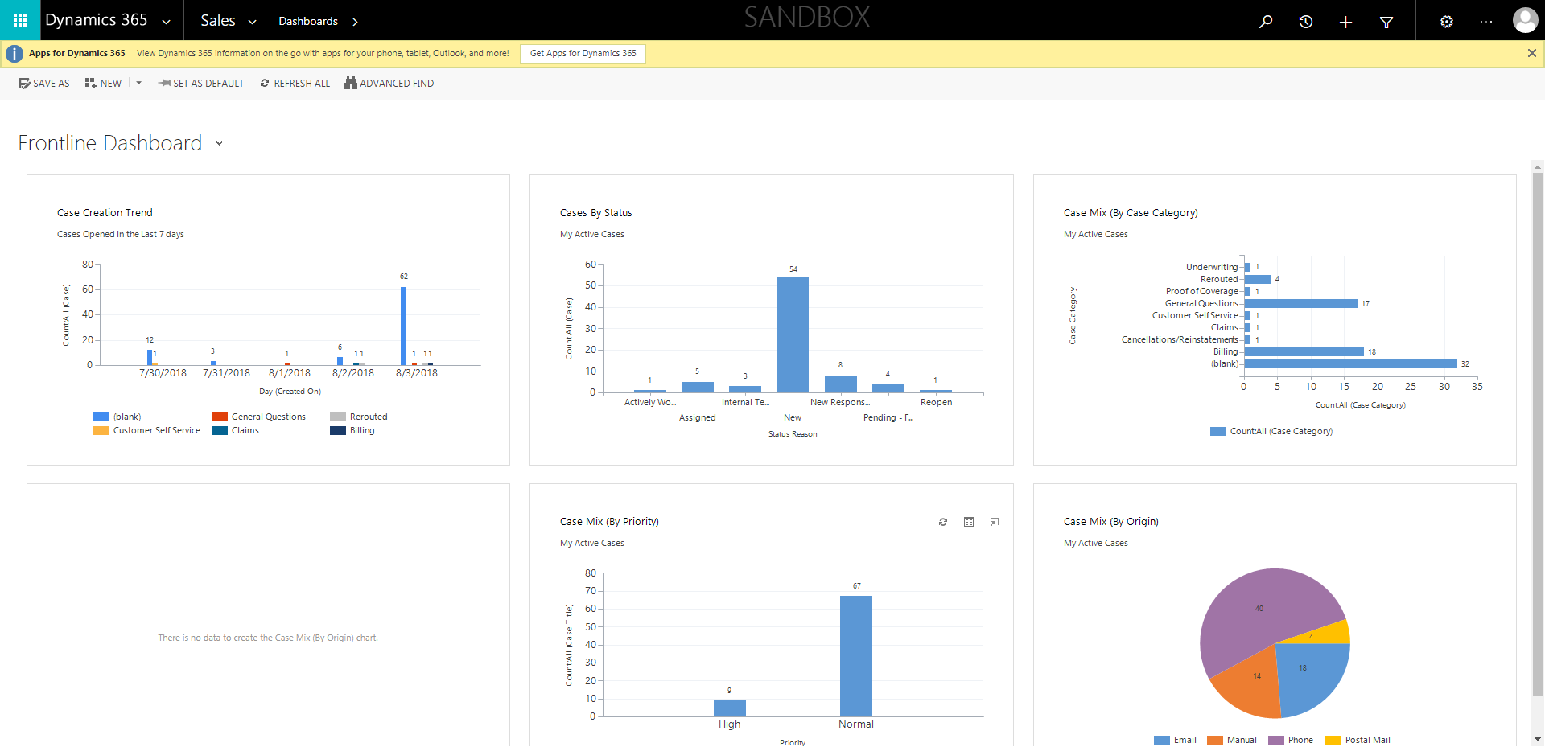

CaseManagement_CreationOfCase_Instance23_06-Aug-2018_02-44-42_AM_MouseClickActionMoveToElementBycssSelectoranavcases.png

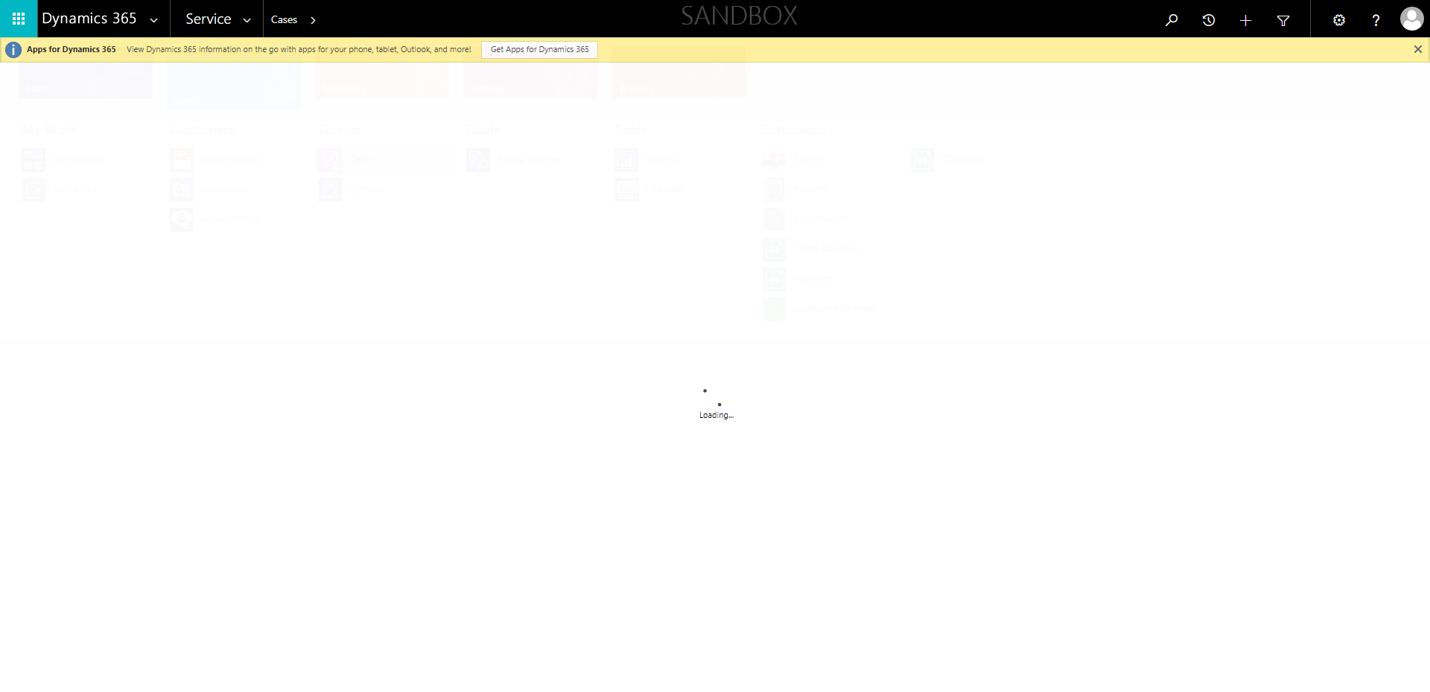

CaseManagement_CreationOfCase_Instance23_06-Aug-2018_02-44-40_AM_MouseClickActionMoveToElementBycssSelectorspanTabSFA.png

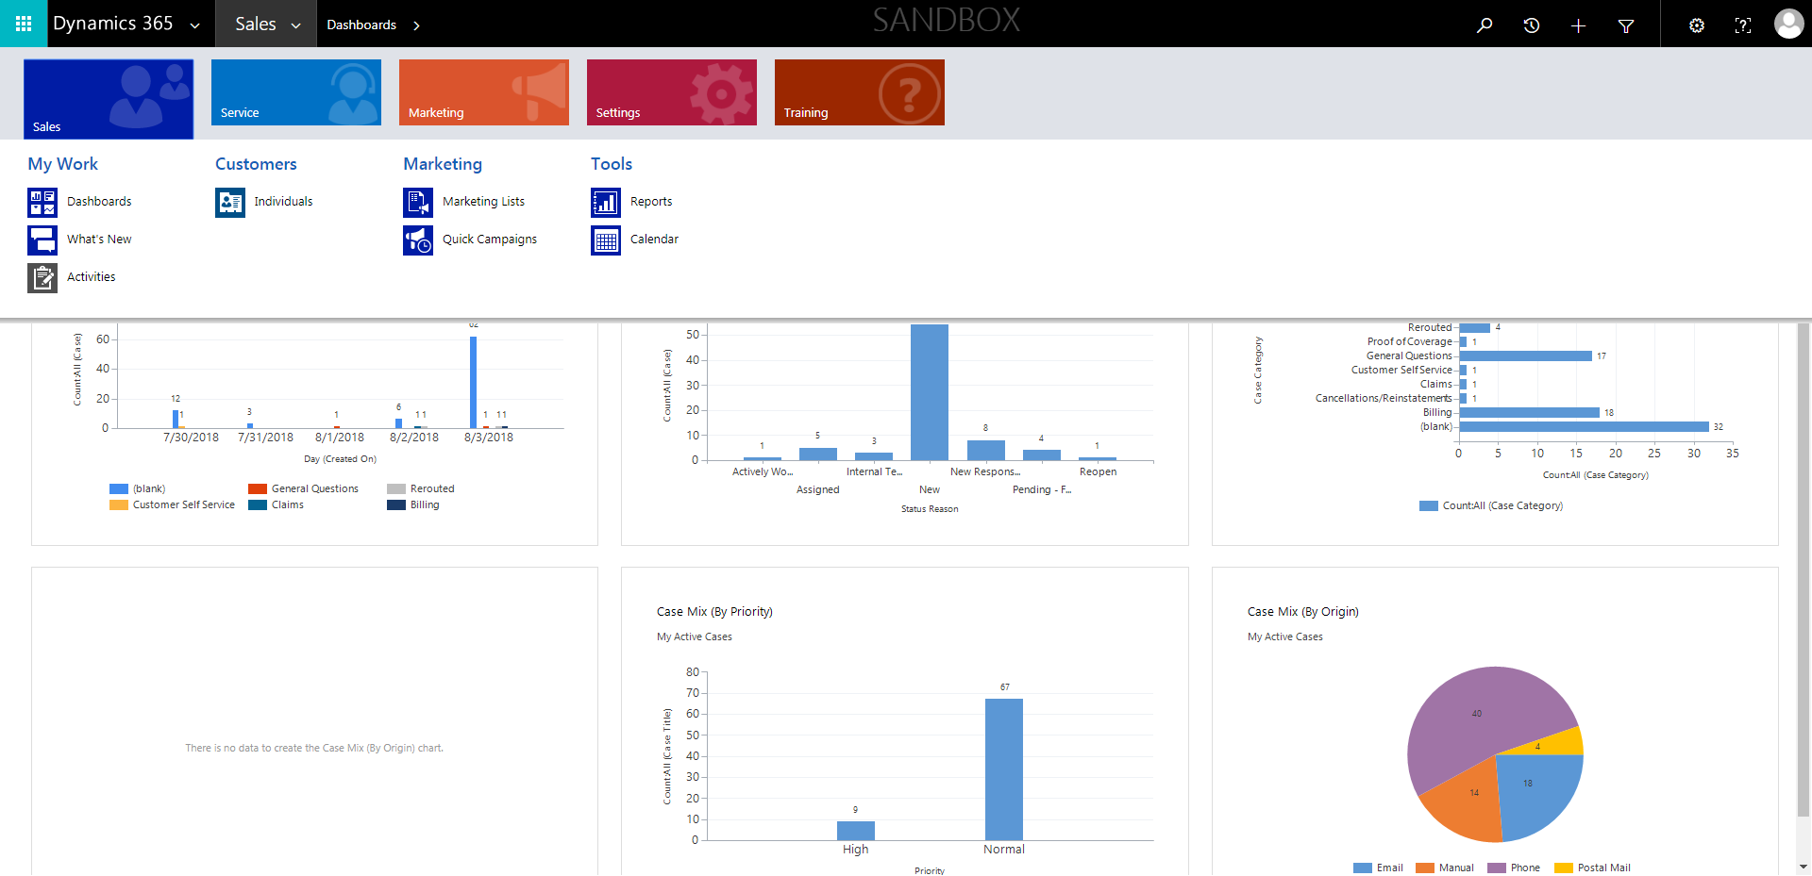

CaseManagement_CreationOfCase_Instance23_06-Aug-2018_02-45-06_AM_MouseClickActionMoveToElementBycssSelectorspanTabCS.png

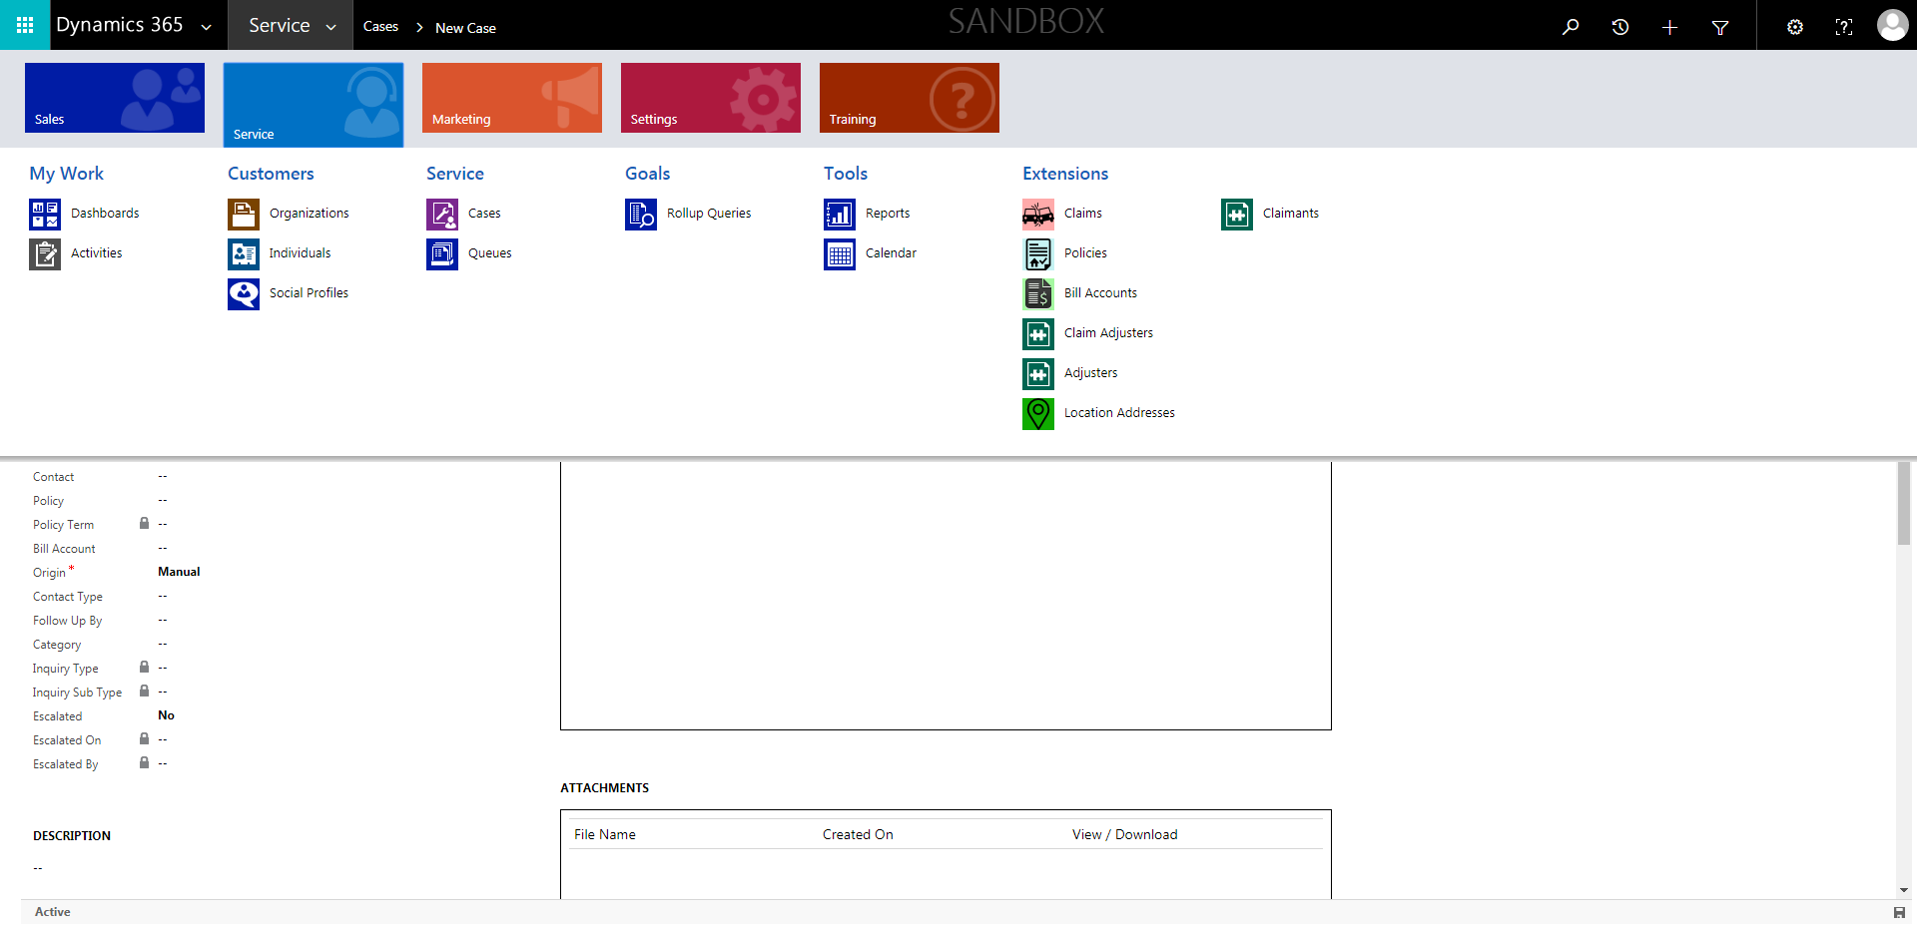

CaseManagement_CreationOfCase_Instance23_06-Aug-2018_02-44-14_AM_MouseClickActiononStaleElement.png

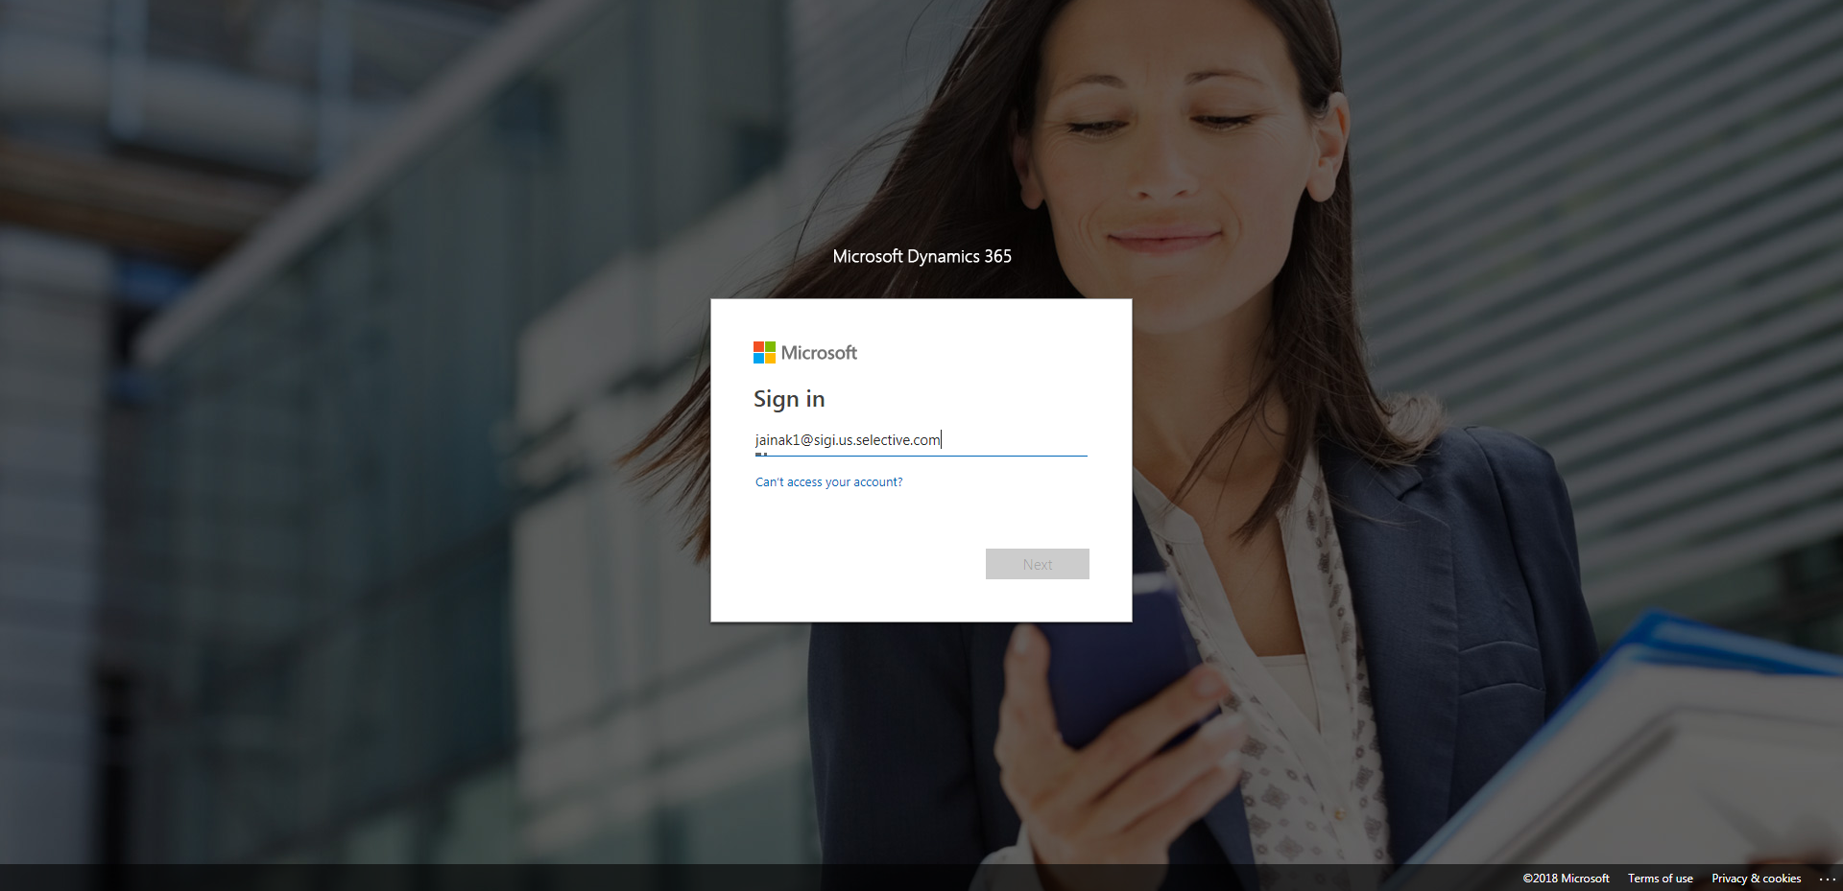

CaseManagement_CreationOfCase_Instance23_06-Aug-2018_02-45-07_AM_MouseClickActionMoveToElementByxpathimgaltServiceparentspan.png

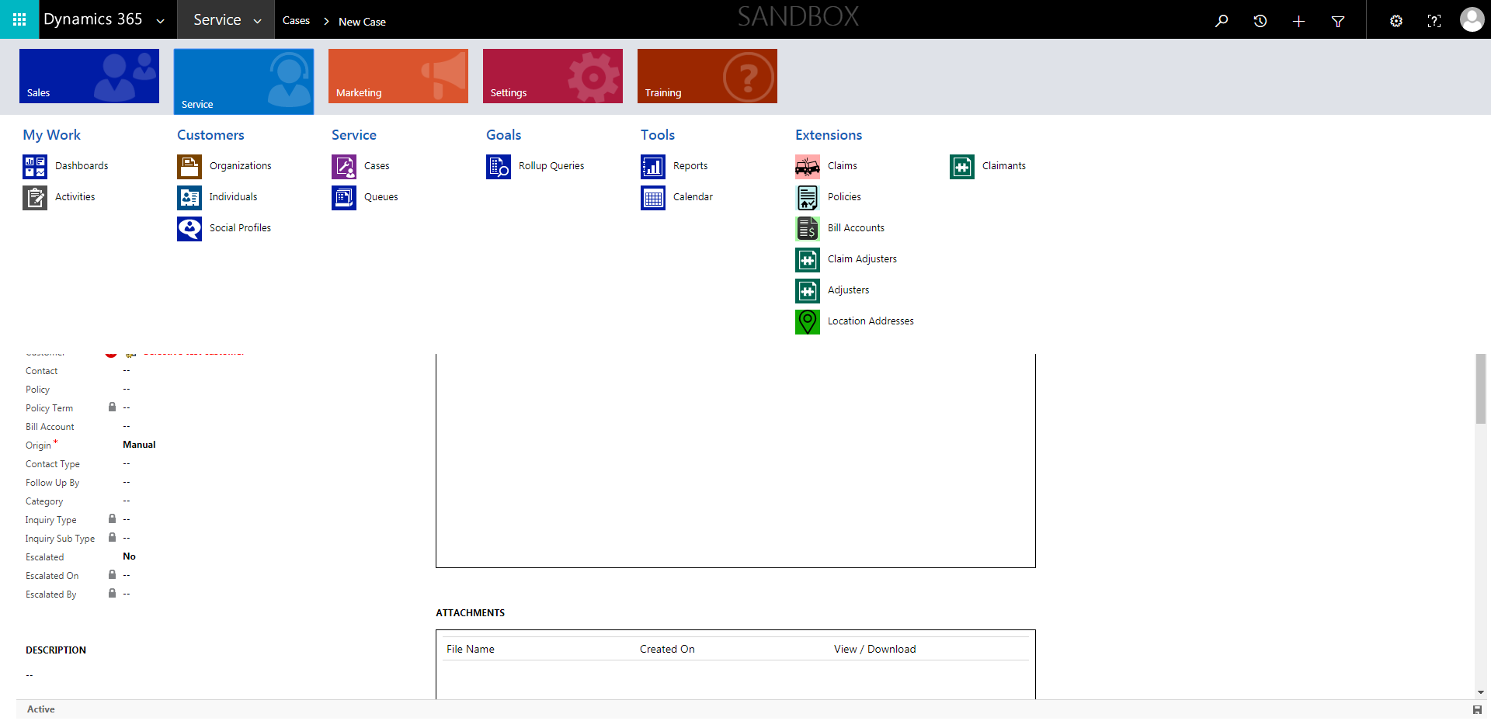

CaseManagement_CreationOfCase_Instance23_06-Aug-2018_02-44-41_AM_MouseClickActionMoveToElementByxpathimgaltServiceparentspan.png

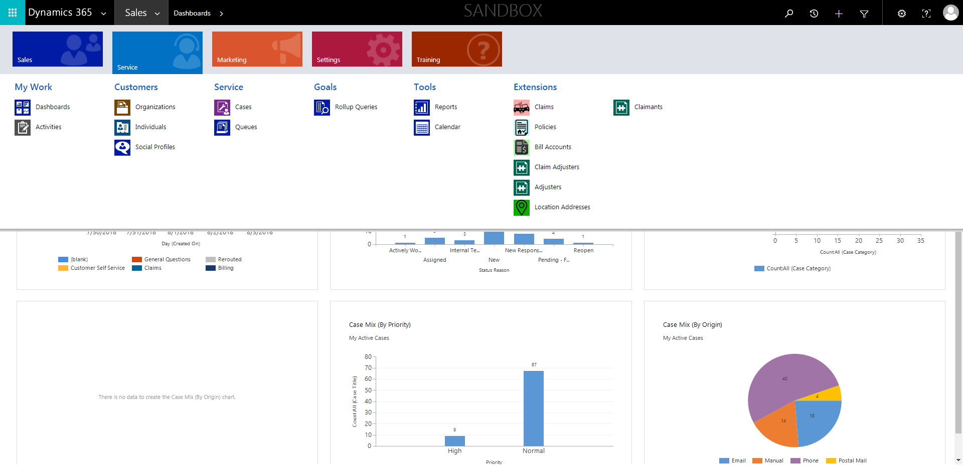

CaseManagement_CreationOfCase_Instance23_06-Aug-2018_02-44-33_AM_SingleSignOn.png

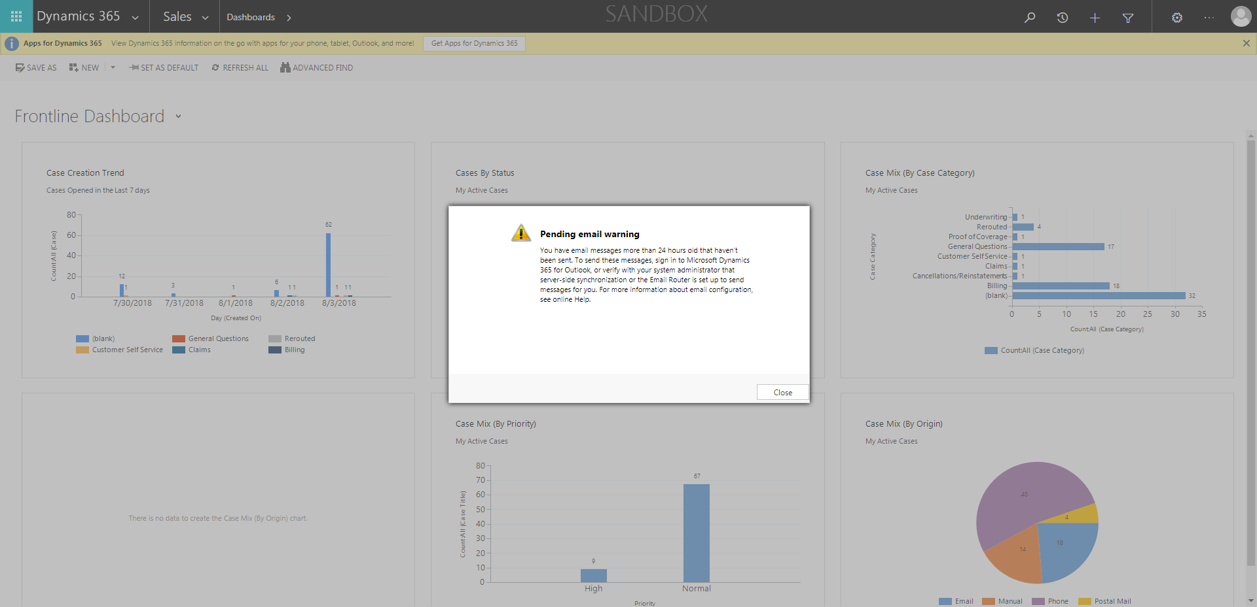

CaseManagement_CreationOfCase_Instance23_06-Aug-2018_02-44-12_AM_EnterTextAction.png

